**Transfer learning using ResNet50 and ResNet18**

|  |  |  |  |  |  |
| --- | --- | --- | --- | --- | --- |
| Experiment Number | Parameters | Transfer Learning model | Added layers | Transforms on dataset | result |
| 1 | Train Batch size = 32  Test batch size = 32  Epochs = 20  Learning Rate = 0.01  Momentum = 0.5 | ResNet18  Fine tuning the convnet | Linear  ReLU  Dropout  linear  Dropout  Linear | Resize -> 224 | Train/Test split = 85:15  Size of dataset = 3,929  Train average loss = 0.45  Test average loss = 0.46  Test accuracy = 75% |
| 2 | Train Batch size = 32  Test batch size = 32  Epochs = 20  Learning Rate = 0.01  Momentum = 0.5 | ResNet18  as fixed feature extractor | Linear  ReLU  Dropout  linear  Dropout  Linear | Resize -> 224 | Train/Test split = 85:15  Size of dataset = 3,929  Train average loss = 0.46  Test average loss = 0.43  Test accuracy = 81% |
| 3 | Train Batch size = 32  Test batch size = 32  Epochs = 20  Learning Rate = 0.01  Momentum = 0.5 | ResNet50  Fine tuning the convnet | Linear  ReLU  Dropout  linear  Dropout  Linear | Resize -> 224 | Train/Test split = 85:15  Size of dataset = 3,929  Train average loss = 0.46  Test average loss = 0.47  Test accuracy = 74% |
| 4 | Train Batch size = 32  Test batch size = 32  Epochs = 20  Learning Rate = 0.01  Momentum = 0.5 | ResNet50  as fixed feature extractor | Linear  ReLU  Dropout  linear  Dropout  Linear | Resize -> 224 | Train/Test split = 85:15  Size of dataset = 3,929  Train average loss = 0.53  Test average loss = 0.47  Test accuracy = 65% |
| 5 | Train Batch size = 16  Test batch size = 16  Epochs = 20  Learning Rate = 0.01  Momentum = 0.5 | ResNet18  Fine tuning the convnet | Linear  ReLU  Dropout  linear  Dropout  Linear | Resize -> 224 | Train/Test split = 85:15  Size of dataset = 3,929  Train average loss = 0.65  Test average loss = 0.66  Test accuracy = 65% |
| 6 | Train Batch size = 16  Test batch size = 16  Epochs = 20  Learning Rate = 0.01  Momentum = 0.5 | ResNet18  as fixed feature extractor | Linear  ReLU  Dropout  linear  Dropout  Linear | Resize -> 224 | Train/Test split = 85:15  Size of dataset = 3,929  Train average loss = 0.47  Test average loss = 0.46  Test accuracy = 73% |
| 7 | Train Batch size = 16  Test batch size = 16  Epochs = 20  Learning Rate = 0.01  Momentum = 0.5 | ResNet50  Fine tuning the convnet | Linear  ReLU  Dropout  linear  Dropout  Linear | Resize -> 224 | Train/Test split = 85:15  Size of dataset = 3,929  Train average loss = 0.47  Test average loss = 0.43  Test accuracy = 78% |
| 8 | Train Batch size = 16  Test batch size = 16  Epochs = 20  Learning Rate = 0.01  Momentum = 0.5 | ResNet50  as fixed feature extractor | Linear  ReLU  Dropout  linear  Dropout  Linear | Resize -> 224 | Train/Test split = 85:15  Size of dataset = 3,929  Train average loss = 0.65  Test average loss = 0.66  Test accuracy = 65% |
| 9 | Train Batch size = 8  Test batch size = 8  Epochs = 20  Learning Rate = 0.001  Momentum = 0.5 | ResNet18  Fine tuning the convnet | Linear  ReLU  Dropout  linear  Dropout  Linear | Resize -> 224 | Train/Test split = 85:15  Size of dataset = 3,929  Train average loss = 0.07  Test average loss = 0.16  Test accuracy = 96% |
| 10 | Train Batch size = 8  Test batch size = 8  Epochs = 20  Learning Rate = 0.001  Momentum = 0.5 | ResNet18  as fixed feature extractor | Linear  ReLU  Dropout  linear  Dropout  Linear | Resize -> 224 | Train/Test split = 85:15  Size of dataset = 3,929  Train average loss = 0.32  Test average loss = 0.25  Test accuracy = 90% |
| 11 | Train Batch size = 8  Test batch size = 8  Epochs = 20  Learning Rate = 0.001  Momentum = 0.5 | ResNet50  Fine tuning the convnet | Linear  ReLU  Dropout  linear  Dropout  Linear | Resize -> 224 | Train/Test split = 85:15  Size of dataset = 3,929  Train average loss = 0.19  Test average loss = 0.17  Test accuracy = 94% |
| 12 | Train Batch size = 8  Test batch size = 8  Epochs = 20  Learning Rate = 0.001  Momentum = 0.5 | ResNet50  as fixed feature extractor | Linear  ReLU  Dropout  linear  Dropout  Linear | Resize -> 224 | Train/Test split = 85:15  Size of dataset = 3,929  Train average loss = 0.35  Test average loss = 0.30  Test accuracy = 85% |
| 13 | Train Batch size = 8  Test batch size = 8  Epochs = 20  Learning Rate = 0.001  Momentum = 0.5 | ResNet18  Fine tuning the convnet | Linear  ReLU  Dropout  linear  Dropout  Linear | Resize -> 224  Normalize( mean = [0.485,0.456,0.406] , std= [0.229,0.224,0.225]) | Train/Test split = 85:15  Size of dataset = 3,929  Train average loss = 0.07  Test average loss = 0.2  Test accuracy = 92% |
| 14 | Train Batch size = 8  Test batch size = 8  Epochs = 20  Learning Rate = 0.001  Momentum = 0.5 | ResNet50  Fine tuning the convnet | Linear  ReLU  Dropout  linear  Dropout  Linear | Resize -> 224  Normalize( mean = [0.485,0.456,0.406] , std= [0.229,0.224,0.225]) | Train/Test split = 85:15  Size of dataset = 3,929  Train average loss = 0.17  Test average loss = 0.14  Test accuracy = 95% |
| 15 | Train Batch size = 8  Test batch size = 8  Epochs = 20  Learning Rate = 0.001  Momentum = 0.5 | ResNet18  Fine tuning the convnet | Linear  ReLU  Dropout  linear  Dropout  Linear | Resize -> 224  Random Horizontal Flip | Train/Test split = 85:15  Size of dataset = 3,929  Train average loss = 0.09  Test average loss = 0.14  Test accuracy = 96% |
| 16 | Train Batch size = 8  Test batch size = 8  Epochs = 20  Learning Rate = 0.001  Momentum = 0.5 | ResNet50  Fine tuning the convnet | Linear  ReLU  Dropout  linear  Dropout  Linear | Resize -> 224  Random Horizontal Flip | Train/Test split = 85:15  Size of dataset = 3,929  Train average loss = 0.16  Test average loss = 0.15  Test accuracy = 95% |
| 17 | Train Batch size = 8  Test batch size = 8  Epochs = 20  Learning Rate = 0.001  Momentum = 0.5 | ResNet18  Fine tuning the convnet | Linear  ReLU  Dropout  linear  Dropout  Linear | Resize -> 224  Random Horizontal Flip  Normalize( mean = [0.485,0.456,0.406] , std= [0.229,0.224,0.225]) | Train/Test split = 85:15  Size of dataset = 3,929  Train average loss = 0.10  Test average loss = 0.14  Test accuracy = 97% |
| 18 | Train Batch size = 8  Test batch size = 8  Epochs = 20  Learning Rate = 0.001  Momentum = 0.5 | ResNet50  Fine tuning the convnet | Linear  ReLU  Dropout  linear  Dropout  Linear | Resize -> 224  Random Horizontal Flip  Normalize( mean = [0.485,0.456,0.406] , std= [0.229,0.224,0.225]) | Train/Test split = 85:15  Size of dataset = 3,929  Train average loss = 0.16  Test average loss = 0.21  Test accuracy = 92% |
| 19 | Train Batch size = 8  Test batch size = 8  Epochs = 30  Learning Rate = 0.0001  Momentum = 0.5 | ResNet18  Fine tuning the convnet | Linear  ReLU  Dropout  linear  Dropout  Linear | Resize -> 224  Random Horizontal Flip  Normalize( mean = [0.485,0.456,0.406] , std= [0.229,0.224,0.225]) | Train/Test split = 85:15  Size of dataset = 3,929  Train average loss = 0.02  Test average loss = 0.14  Test accuracy = 97% |
| 20 | Train Batch size = 8  Test batch size = 8  Epochs = 30  Learning Rate = 0.0001  Momentum = 0.5 | ResNet50  Fine tuning the convnet | Linear  ReLU  Dropout  linear  Dropout  Linear | Resize -> 224  Random Horizontal Flip  Normalize( mean = [0.485,0.456,0.406] , std= [0.229,0.224,0.225]) | Train/Test split = 85:15  Size of dataset = 3,929  Train average loss = 0.013  Test average loss = 0.15  Test accuracy = 96% |

**Experiment 19 plots:(ResNet18)**

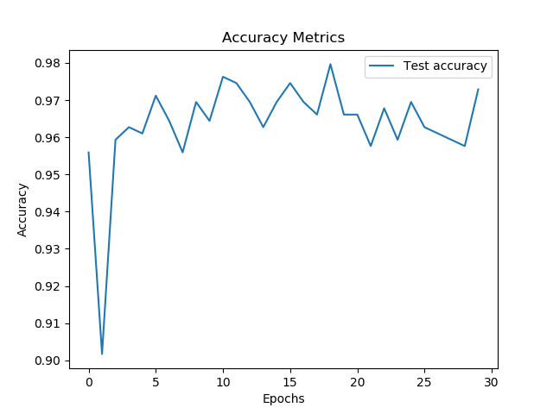

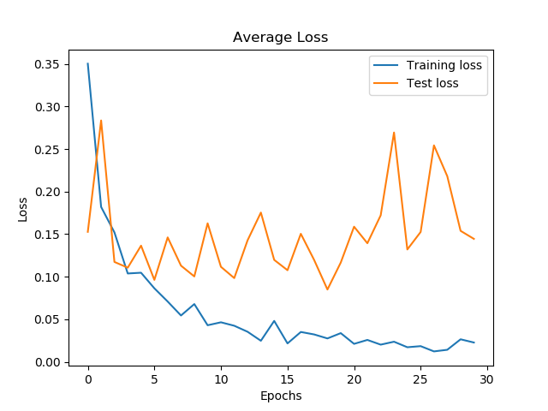

**Experiment 20 plots:(ResNet20)**

